**REPORT OF NAYI DISHAYEIN WINTER SCHOOL, SAMBHAAVNAA**

**25 to 31st December, 2013**

[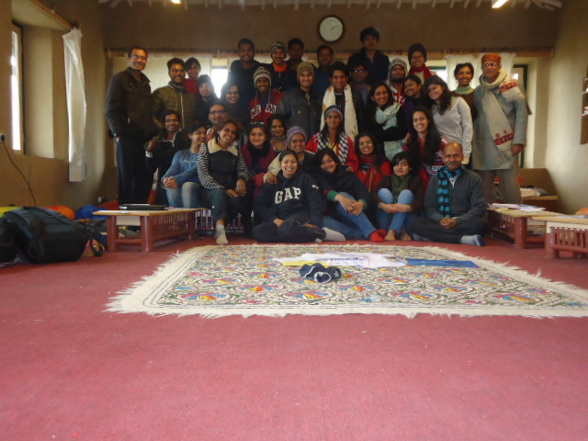](http://www.sambhaavnaa.org/wp-content/uploads/2013/09/DSC02720.jpg)

“Nayi Dishayein: Winter School,2013”  was organized in the middle of a cozy winter for a group of warm spirited youth who came from different parts of the country to the Sambhaavnaa Institute. The task was to challenge the youth who were largely from the upper or upper middle class.

**Challenge**

The group was fairly homogeneous by caste, class, and other divisions of our society, with a equal girl-boys ratio. Yet they brought in excitement and energy to the sessions and everybody started enjoying and involved themselves actively throughout  the day followed by post session discussions, long debates and singing songs around the fireplace

While the topics and issues discussed were not new to the participants as they had a decent amount of academic understanding of these issues and a  lot of them had also worked in social sphere, it was still a  challenge  to raise discussions about the various protests, based on caste, class, race, gender issues, on development and its consequences and direct them to the realities in the ground.

**Itenary**

After a discussion with the participants, it was decided not to put the itenary of all the days. Some parts of it used to be told a day before in the last session of the day. There was an attempt to increase the time of Physical labour. This was done specifically to get brainstorming equivalent to hand storming. Within Sambhaavnaa Institute there was opportunity to work with stone and wood and also dig, which the charged youth happily accepted .This ‘hand storming’ was made possible by cutting of time from Breakfast and Lunch. A voluntary Yoga session was also kept in the morning everyday, which was attended by 2-4 youth with the guidance of Vimal bhai. In other words, the rules and regulation helped provide the framework and discipline for these young minds to discuss and understand each other and also to collaboratively join struggles happening on the ground,.

[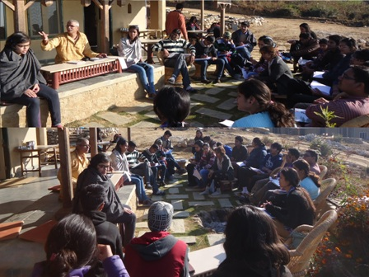](http://www.sambhaavnaa.org/wp-content/uploads/2013/09/DSC02514-002.jpg)

**It was different..**

This wasn't like a NGOs workshop or a holiday school. It was on a different note. It was largely linking the theory that the young have read with actual practice. It’s helped to get the academics to know the realities of the field.

Unfortunately, there were few of fellows/ resource faculty (Mr.  Ashish Kothari, Mr. KulbhusanUpmanyu who couldn’t join due to health reasons. They were missed but the others stepped in to fill the gaps.Finally, on the last day, everybody wondered that “Samay hi Kahan Tha” (Where was the time?)

There were few issues that could have been discussed on a larger sphere and longer discussion but we had to prohibit that due to time constraints. **However, it was a positive sign that people wanted to discuss over such issues.**

**Methodology: Songs and Films**

Daily a few songs taken from the People Protests movements were introduced and sung. This served the dual role of making youth understand those issues as well as tap their feet and sing to the song rhythm. They were well versed with about three songs by the last day.

Films like Dharma, Story of Stuff, Samvidhaan and In the name of Development helped participants to dwell deeper into the issue and broaden their horizons.

[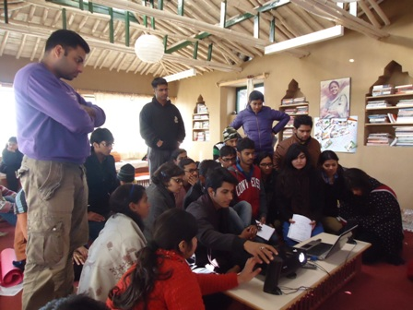](http://www.sambhaavnaa.org/wp-content/uploads/2013/09/DSC02570-003.jpg)

The sessions were divided into three different formats which were serious discussions and deliberations, issue based activities along with some fun activities and actual field labor.

The entire day’s schedule was connected with a day of reflection in the end

**Some highlights of the seven days:**

* After an introduction of all the participants and of the Sambhaavnaa to them, an activity of Trust walk was conducted by Sumit and ManshiAshar which made youth more comfortable with each other.
* One of sessions led the participants to discuss concepts like freedom, equality, Justice, democracy, development in different groups.
* Ashish Kothari’s presentation on Indian Economy through video was conducted by Vimal bhai.
* Manshi Ashar led an activity on social identity.
* Vimal bhai  carried over the discussion on the ongoing struggles and movements across the country
* Advocate Abhimanyu gave a talk on Enviornmental Law.
* Manshi Ashar and Vimal Bhai  conducted a session on Energy and dam .
* Saritji took a session on governance and democracy and presented a case study on the presently popular AAP of Delhi.
* After which Vimal Bhai took an open air session on Gandhi ji and his ideology.
* There was a half day physical labor activity conducted on a day after which there was a session on minimum wages where the discussions were closer to ground realities because of the experience our youths had just faced. This was taken by Saritji
* Manshi Asher took a workshop on “How to build a campaign” where our youths were given various situations to helpthemunderstand the differences in the kinds of struggle and the entire ideology behind it.
* The evening session of that day dealt with Politics of Consumerism by Vimal bhai with an exercise whereby one had to write one’s own assets, and categorize it into the most needed assets and the extras and hence gave a judgment to everybody of the optimality of our consumption.
* Sheila and Vimal Bhai lead a session on “Social, Inequality, Religion and Communalism”. A small exercise of reciting small prayers from all religions wasdone without letting them know which particularly belonged to which religion. When they were asked to distinguish, they could not, thereby explaining the similarity of ethics in all our religion.
* The discussion started off with this and went to various religious issues of our country, exploring the communal disasters in Gujrat, Mujjafarnagar, Kandmal and the intolerance that has grown in various society. The necessity of communal harmony was understood and felt after this session by all the youth.
* Nidhi, Seela and Jaya Bharti took a session on Gender and Queer politics where they based an analogy with an interesting rabbit story in the beginning. Everybody got involved in its interpretations but it remained a riddle till the end. The understanding of gender, sex and sexuality was first asked by the youth and then elaborated by the session leaders.
* Vimala Vishwapremi  gave a presentation on “Social Inequality: Class, Caste, Dalit Women” and discussed the problems of Dalit in Himachal Pradesh.

**The “End day”**

The weather on the last day was colder because of rains and snowfall in the mountains in vicinity because of which People’s parliament program could not be conducted outdoors. Saritjiinstead, took a session of parliament on deciding the minimum wages indoors in the room itself.  Everybody gave their reflections and shared their experience in a quick reflection session.

[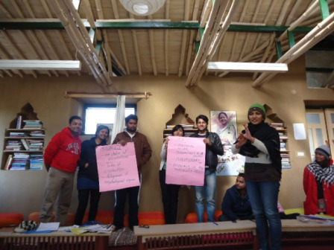](http://www.sambhaavnaa.org/wp-content/uploads/2013/09/DSC02621-004.jpg)

With this workshop theresultant  sensitization towardsissues can be seen in these youth.It can be seen that there have been many movements against the elite section of the society by the people of the same section like Gautam Buddha and Mahavira in their own time. Perhaps, it is easier and more possible to see the cruelty and unconcerned nature of the higher class when you belong to that class which if guided and held well, can help in reformation and a strive towards a more beautiful country in its thought and action.

**Hope**

Hope some of the youth from this school will join peoples' movements/ or give some of their time in its cause. Many of them have thought about bringing small but significant changes in their life style. But there is a need to have a constant touch with them.

**Participants:**

|  |  |
| --- | --- |
| **Name** | **College/University** |
| Anshul S. Bharma | Jamia |
| Isha Suri | Maharishi Dayanand University in 2009. |
| Payoshini Kulkarni | Fergusson college, pune |
| Yogini Oke | West Bengal National University of Juridical Sciences at Kolkata |
| Garima Singhal | Ramjas College, Delhi University |
| Aditi Patil | Ganpat University, Gujarat |
| Aditi Singh | National Institute of FashionTechnology, Bangalore |
| Krishnamurari  Mukherjee | Department of Political Science( University of Delhi) |
| Piyush Ghosh | State Government College, B.A |
| Gaurav Awasthi | DBA, Awadhesh Pratap Singh University, Rewa |
| Pratik  Thakur | Delhi University |
| Adhavan .P.R | Entrepreneurship Development Institute of India, B.com, Loyola college, Chennai.(2010) |
| Rahul  Singla | IIT-BHU |
| Surabhi Jha | IIT-Delhi |
| Sushmita V Gopalan | IIT Madras |
| Narendra Patil | B.Tech in Mechanical |
| Amit Kumar | Delhi University. |
| Shrenik Sanghvi | IIT Kharagpur |
| Ayush Pandey | B.A. honors Economics |
| Gulshan Banas | Lady Shri Ram College for Women, Delhi University |
| Hemali Chothani | Entrepreneurship Development Institute of India, Gandhinagar, Gujarat. |
| Vinayak Rajesekhar | Hansraj College, University of Delhi |
| Mayank Jyoti Verma | IIT Delhi |
| Trijita mukharjee | Lady Sri Ram College, Delhi University |
| kishlay kushwaha | IITDelhi |
| Salma Ansari | Bachelors in management studies. since the past 4 years |
| Abdul Aziz. M | College of Arts & Science in Bangalore |
| P.Pavitara | SASTRA UNIVERITY |
| Ashu Chauhan | NAPM |